Yield Canned Report
Initial Data Analysis
Progress Report: 10/30/17

1 Goal
The goal of this canned report was to provide up-to-date analysis on COB inventory and product yields. It ideally should be able to assess the value of COB units in inventory, weighted against the orders for each end product, and the test results of each COB unit.
Overall Report Calculation:
- Assign Value to each COB unit (≥ 1 predictive metric)
- Assign Weight to Inventory Channel (≥1 historical metric / predictive metric)
- Calculate Value of Each Inventory (sum of predictive scores * weight)

2 Parameters
Here are listed some of the potentially useful parameters to be used in calculating the value of COB units in inventory
- Order history of end products
  - Used to calculate the likelihood of a COB unit being used to fulfil an end product
- COB test data
  - Used as a predictive scoring metric for the COB unit
  - Requires a strongly correlated actual scoring metric to be predictive
- Time spent in inventory
  - Used as an actual scoring metric for the COB unit
  - Only useful if higher quality COB units are used sooner than poorer quality COB units (as opposed to units being selected at random, for example)
- LM test data
  - Also used as an actual scoring metric for the COB unit
  - Depends on proper correlations between COB test data and LM test data

3 Pseudo-Calculations
Here are some of the potential calculations that can be made with the parameters. Our goal is to have at least 1 predictive metric (3.1, 3.2, 3.3), and the weights of each channel (3.4)

3.1 LM Scoring Prediction
This calculation depends on COB test data having correlations with LM test data.
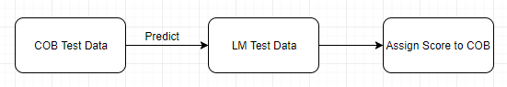
Usefulness:
- If we can predict LM test data by looking at COB test data, we can give COB units in inventory a predicted score while in inventories

3.2 Predicting Time Spent in Inventory By COB Test Data
This calculation depends on COB test data having correlations with the time the COB unit spends in inventory. In other words, it requires that COB units with certain qualities (as shown in their test data) are picked more often/sooner than other units, and that the selection process is not random
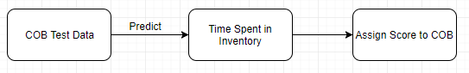
Usefulness:
- Similar to the previous calculation, this would also give us a way to quantitatively score COB units in inventory based on their test data, and predict how likely each unit is to be used

3.3 Distribution of Time Spent in Inventory
This calculation looks for a distribution of time spent in inventory. In other words, it attempts to use how long a unit has spent in inventory as a predictive measure of how much longer it will stay there, or if it will be used at all.
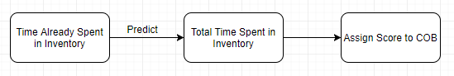
Usefulness:
- Similar to the previous two calculations, this also provides a predictive score

3.4 Historical Order Frequency
This calculation simply looks at historical order rate of certain products.
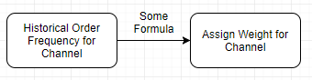
May further look at if there are trends across certain months, etc.
Usefulness:
- Provide weights to each COB inventory

3.5 Final Calculation: Predict Value of COB Unit in Inventory
This calculation requires at least one predictive quality of COB units (3.1, 3.2, 3.3), and the weight of the channel it belongs to (3.4), to assign a value to the unit.
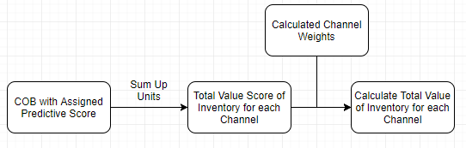
Usefulness:
- This is the goal canned report to be made, which represents the value of each inventory

4 Data
This section outlines where we will retrieve data from.

4.1 COB Test Data
SQL Table: OrtelTE.dbo.ChirpSpecTrumData
Example Query: SELECT TOP 10 * FROM OrtelTE.dbo.ChirpSpecTrumData WHERE Batch='5836220' AND CHIP='CO122'
TestTemp, PredictChannel, SMSR, Chirp

SQL Table: OrtelTE.dbo.LIDataBase
Example Query: SELECT TOP 10 * FROM OrtelTE.dbo.LIDataBase WHERE Batch='5836220'
Ith, Power, Efficiency, WL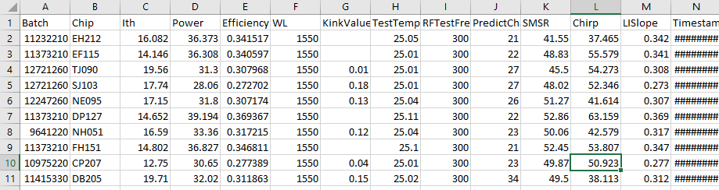

4.2 LM Test Data
SQL Table: OrtelTE.dbo.ModuleFailSMSR
Example Query: SELECT TOP 10 * FROM OrtelTE.dbo.ModuleFailSMSR WHERE Device_SN = 'BFC5265'
WaveLen, SMSR, Ith, Slopeff, Temperature

SQL Table: OrtelTE.dbo.LaserModuleShippingData
Example Query: SELECT TOP 10 * FROM OrtelTE.dbo.LaserModuleShippingData WHERE Device_SN = 'BFC5265'
Chirp
Morteza’s Data
Data from Morteza on LM units was identical to the data in these tables, so we used those
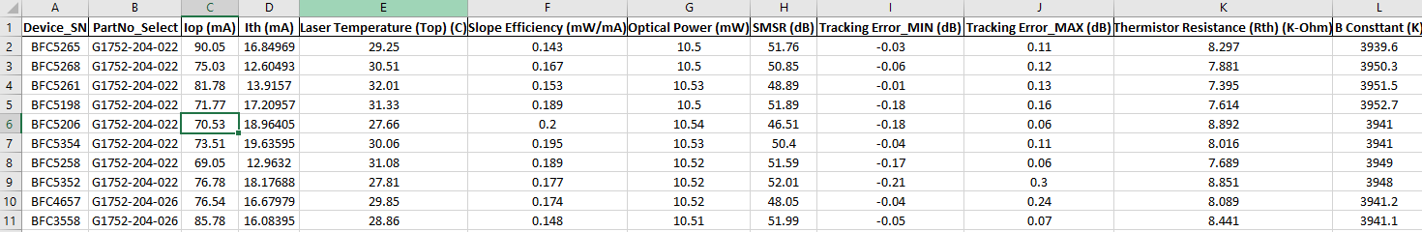

4.3 LM-COB Linking
SQL Table: OrtelTE.dbo.ModuleDistortion
Example Query: SELECT TOP 10 * FROM OrtelTE.dbo.ModuleDistortion WHERE Device_SN = 'BFC5265'
Links LMs with their corresponding COB chip, so we can find the COB test data related to it
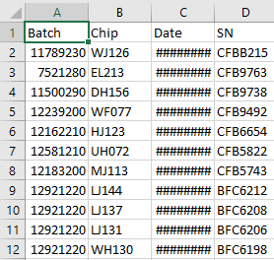

4.4 Historical Order Data
LM Consumption Data:
Data provided by Marc Cavagnolo shows monthly consumption for LMs per channel. This can be considered as a measure of orders for units in each channel
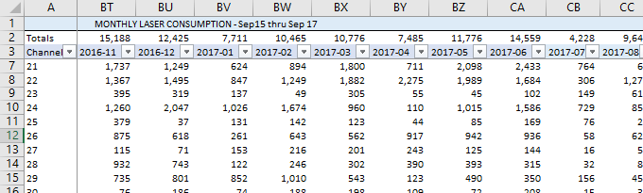

5 Data Collection and Initial Analysis
This section outlines the process of initial data analysis.

5.1 Data Collection Process
- Collect LM serial numbers from Morteza’s data (Section 4.2)
- Collect matching COB batch and chip IDs (Section 4.3)
- Collect COB test data for these units (Section 4.1)
Data for about 10,000 units was collected in this process for analysis

5.2 COB Test Data Initial Check
- Check to see which parameters of COB test data might be useful for analysis
Fig 1. Histogram of All Collected Data Types in COB Data
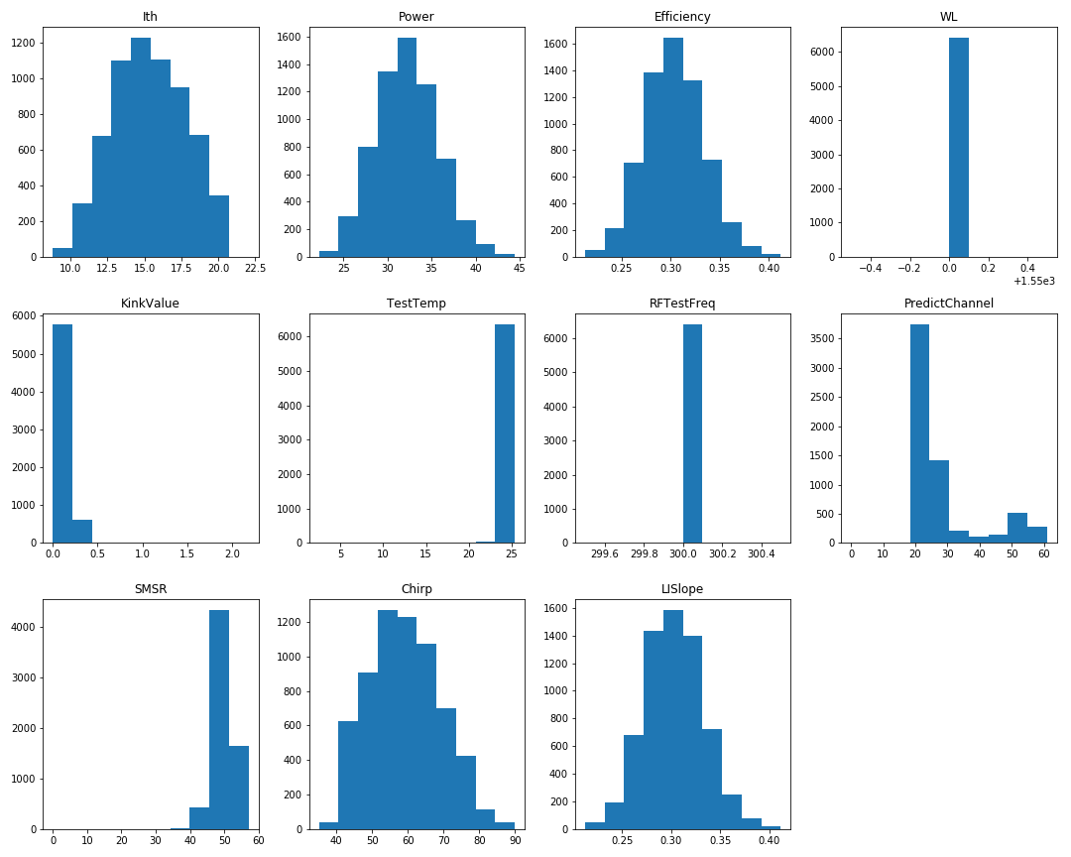
- A few pieces of test data are pretty much always the same value (Wavelength, TestTemp, RFTestFreq)
- PredictChannel is likely based on other values, and is oddly distributed
- Below are the normally distributed pieces of test data, which will be used for analysis
Fig 2. Histogram of Distributed Test Data Types in COB Test Data
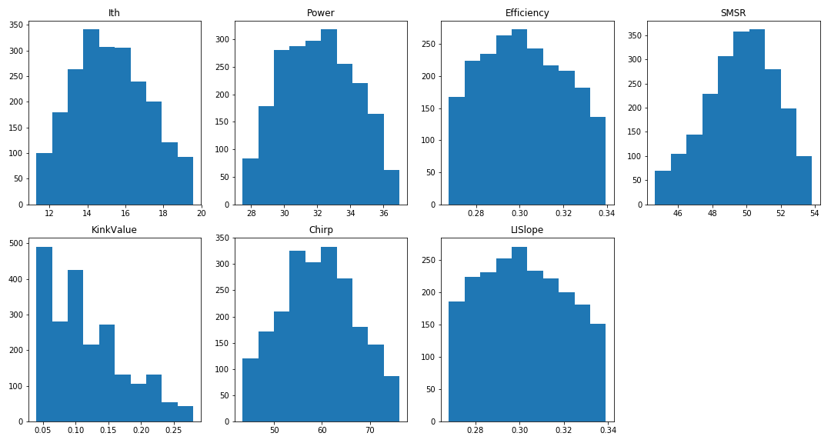

5.3 Data Cleaning
- Remove any rows with missing data in any of the above 7 test data types (Ith, Power, Efficiency, SMSR, Kink, Chirp, LISlope)
- Remove outliers by removing rows where values are outside 1st or 99th percentile (* May revoke this step when running models)

Initial Analysis of Monthly LM Consumption
Corresponds to Section 3.4
- Data collected from Marc Cavagnolo’s LM monthly consumption data
Fig 3. Average Monthly LM Consumption by ITU Channel
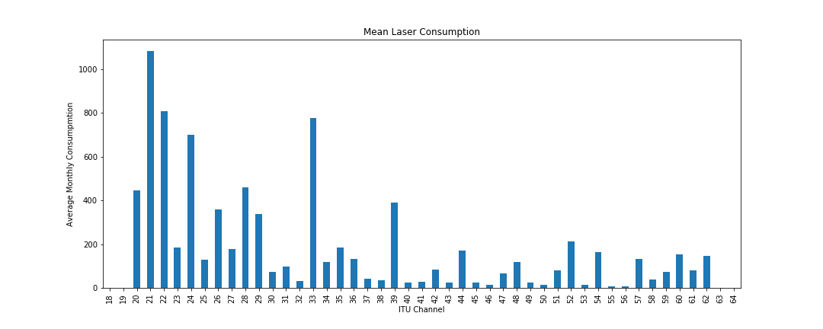
Fig 4. Histograms of Monthly LM Consumption by ITU Channel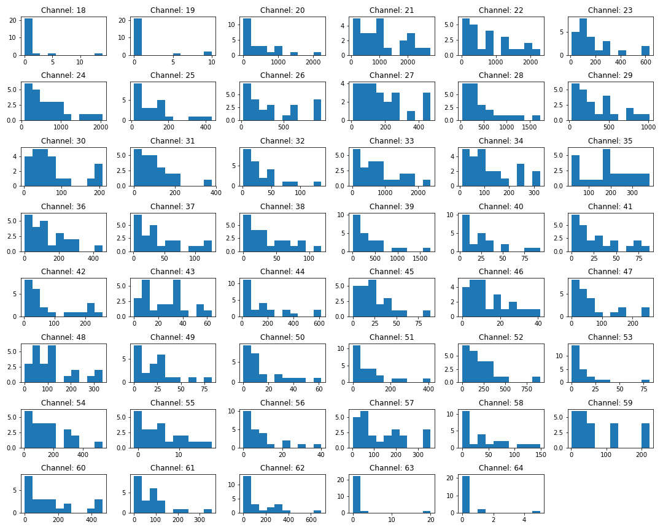

Fig 5. Rolling Average (3 Months) of LM Monthly Consumption By ITU Channel
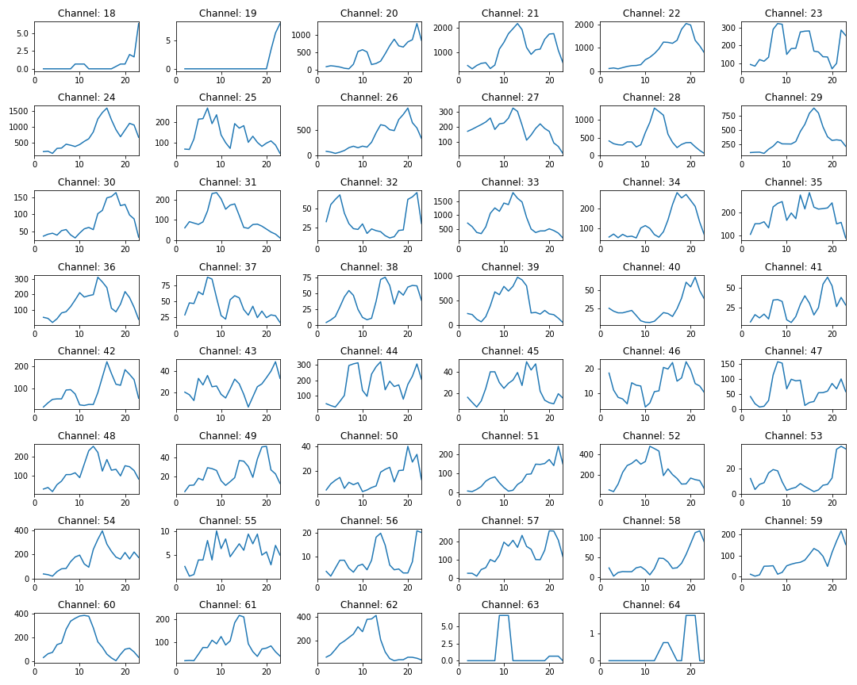
Fig 6. Correlation of Consumption Between One Month and the Next
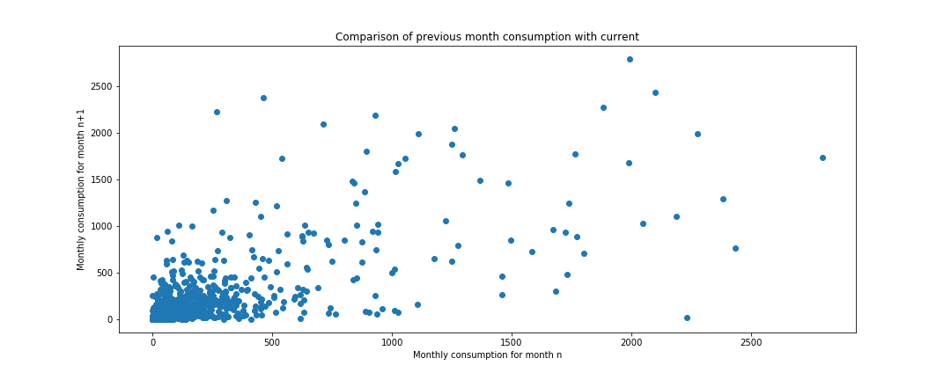

Fig 7. Rolling Average (3 Months) of LM Monthly Consumption By ITU Channel
(Highlighted Mean > 300)
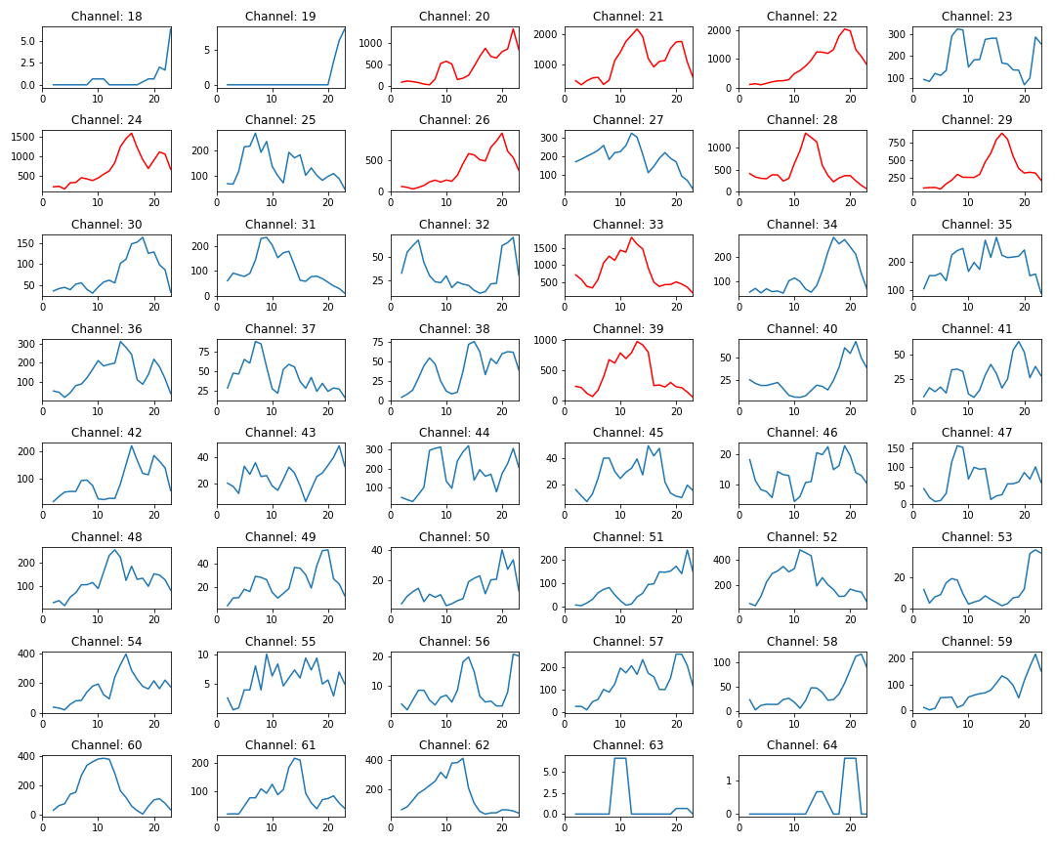

Monthly LM Consumption Conclusions
- It is difficult to predict the next month’s orders based on the previous months (Fig 5, 6)
- Most channels have a positive-skewed normal distribution (Fig 4)
- Historically high order rate is not entirely indicative of future rates (Fig 7, especially channels 28, 29, 33, 39)
- May be helpful for further analysis of channel rolling averages to be normalized against global rolling averages, as it looks like many trends share peaks and troughs
  - Further, looks like some patterns may even be clustered into order patterns (single middle peak, two left/right peaks, generally bumpy), which may indicate different customers

5.5 Initial Analysis of Time Spent in Inventory
Corresponds to Section 3.3
- Calculate time spent in inventory as:
  - (Date of LM test data entry) – (Date of COB test data entry)
  - Test data entry using most recent passed entry
  - May need further refinement of this definition, depending on distribution of analysis

Fig 8. Histogram of COB Time Spent in Inventory
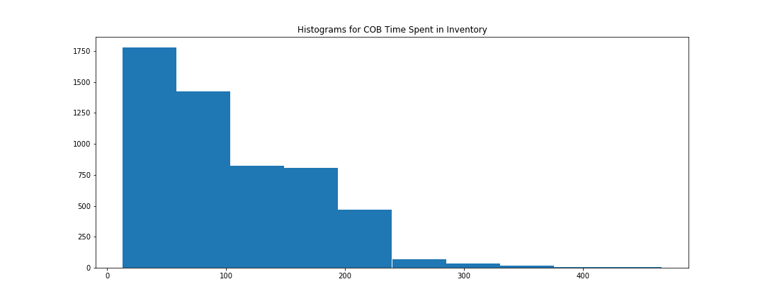
Fig 9. Histogram of COB Time Spent in Inventory (30 Bins)
Higher resolution (smaller group size for histogram bins shows more detail in distribution, but may be more subject to random error) 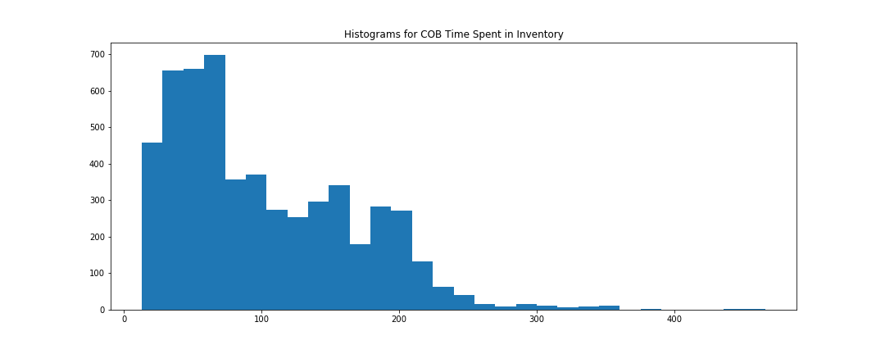

Fig 10. Comparison of COB Test Data Against Time Spent in Inventory
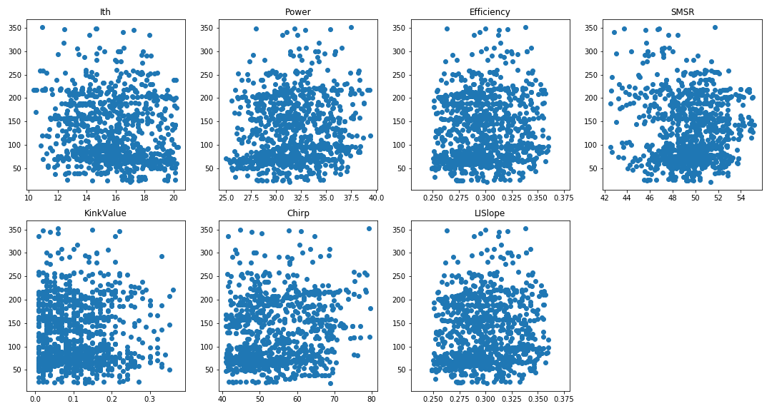

5.5.1 Time Spent in Inventory Conclusions
- Time spent in inventory has a positively-skewed normal distribution, as we might expect (Fig 8, 9)
  - Indicates that most units get chosen early on when put into inventory
  - The longer a unit stays in inventory, the less likely it is to be used
  - Time spent in inventory can be used as a predictive score for likelihood of a unit to be used in the future
- Time spent in inventory does not seem to have correlations with our chosen COB test data
  - These pieces of COB test data cannot be used to predict how long units will stay in inventory for
  - This may also indicate that units are being selected at random with respect to test data?
  - May need to conduct further analysis dividing COB units into groups of their ITU channels (intuitively, we may be choosing COB units with test data appropriate for their ITU channel)

Initial Analysis of COB Test Data Compared Against LM Test Data
Corresponds to Section 3.1
- Goal: Correlate LM Test Data with COB Test Data, to see whether LM Test Data can be predicted
- COB Test Types Used: ['Ith', 'Power', 'Efficiency', 'SMSR', 'KinkValue', 'Chirp', 'LISlope']
- LM Test Types Used (every column from Morteza’s data): ['Iop (mA)', 'Ith (mA)', 'Laser Temperature (Top) (C)', 'Slope Efficiency (mW/mA)', 'Optical Power (mW)', 'SMSR (dB)', 'Tracking Error_MIN (dB)', 'Tracking Error_MAX (dB)', 'Thermistor Resistance (Rth) (K-Ohm)', 'B Consttant (K)', 'CNR @ 61.25 MHz (dB)', 'CNR @ 547.25 MHz (dB)', 'CSO (dB)', 'CTB (dB)', 'Chirp (MHz/mW)', 'Monitor Current (micro-A)', 'Frequency Response (dB)']

- Majority of these LM Test Types had no clear correlation, for example:
Fig 11. COB Test Data vs. LM Frequency Response (dB)
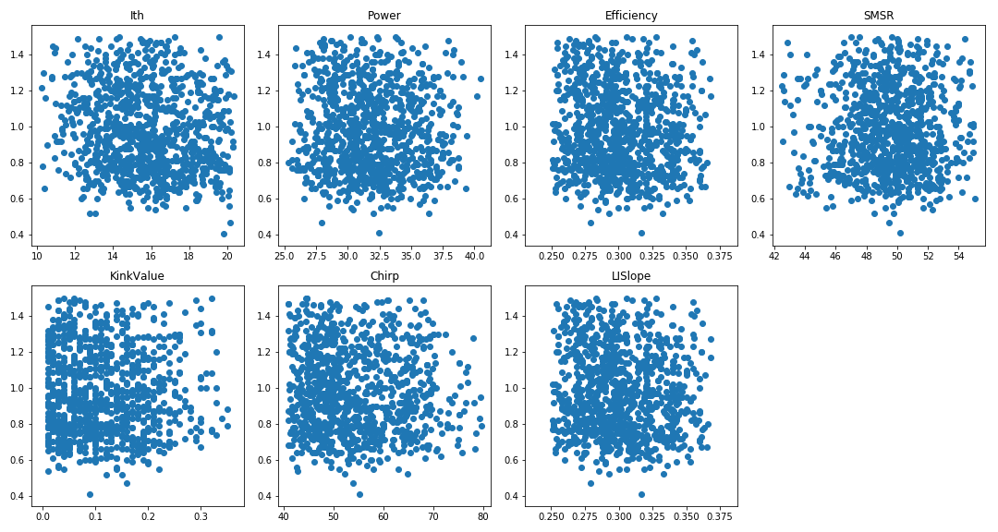
- The only LM Test Types that showed promise were: ['Iop (mA)', 'Ith (mA)', 'Monitor Current (micro-A)', 'Slope Efficiency (mW/mA)', 'SMSR (dB)' ]:

Fig 12. COB Test Data vs. LM Iop (mA)
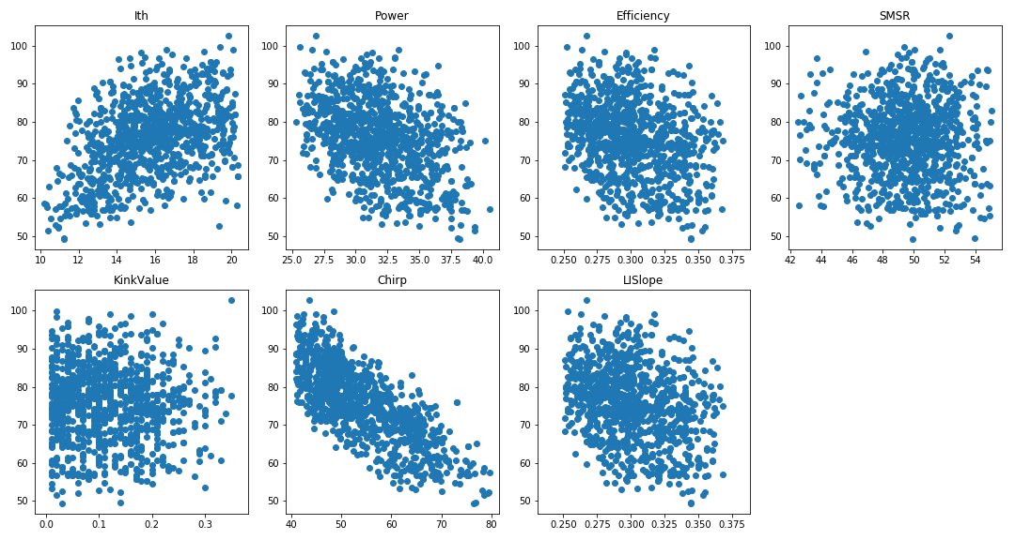

Fig 13. COB Test Data vs. LM Ith (mA)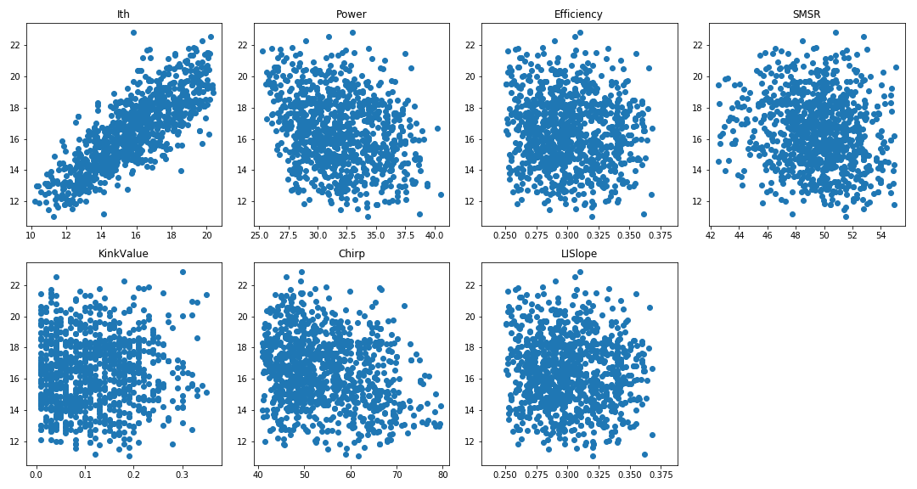

Fig 14. COB Test Data vs. LM Monitor Current (micro-A)
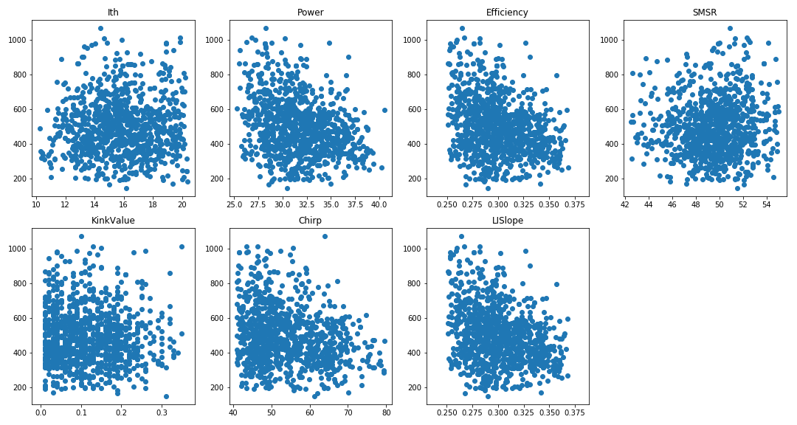

Fig 15. COB Test Data vs. LM Slope Efficiency (mW/mA)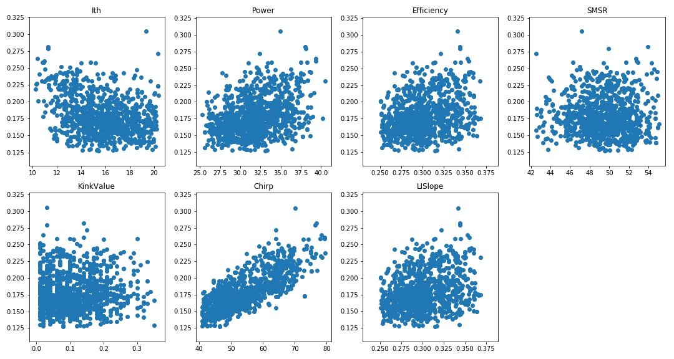

Fig 16. COB Test Data vs. LM SMSR (dB)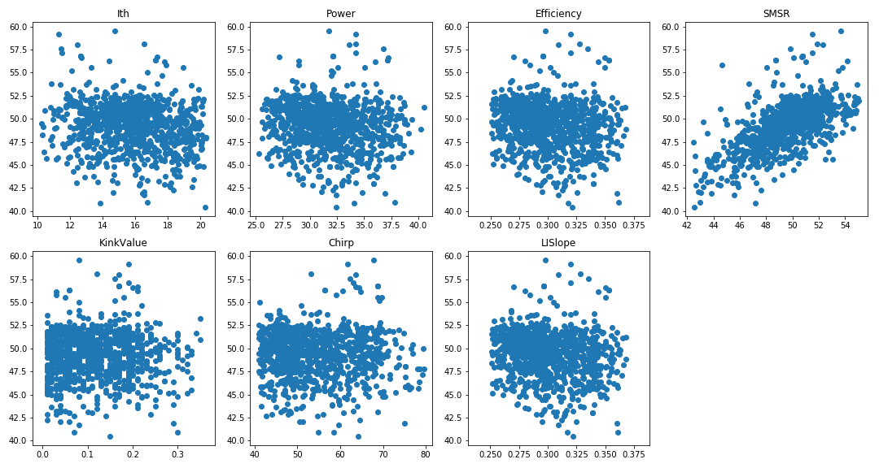

COB-LM Test Data Correlations Conclusions
- SMSR and Ith seem to have correlations between COB and LM stages (Fig 13, 16)
  - Ith also seems to have a small inverse correlation with COB Power and Chirp
- Slope Efficiency, and Iop seem to have other correlations with COB data (Fig 12, 15)
- Monitor Current seems to have general inverse correlations with COB data (Fig 14)
- Unfortunately, some of these correlations look very weak, and are likely to be drowned out by random error if actually attempting to use them for predictions
  - Will have to actually try to model correlations to determine how clear they are

Model Building

6.1 LM and COB Data Collection Detail
Data Collections (Collected 11/16/17)
- COBs where an LM is found with corresponding Chip/Batch IDs (Linked)
- COBs where no corresponding LM is found (Unlinked)
Linked:
- Unique entries without missing data: 107,812
Unlinked:
- Unique entries without missing data: 303,298

Data Columns:
Chip Data: [ 'Chip_TestPwr', 'Chip_LISlope', 'Chip_LIIth', 'Chip_PeakWL', 'Chip_SMSR', 'Chip_Chirp', 'Chip_ModCurrent', 'Chip_ModulationFreq', 'Chip_RFpk', 'Chip_AlignPwr' ]
- Various COB test data from OrtelTE.dbo.ChirpSpecTrumData in SQL
Laser Data: [ 'Laser_RFClipping', 'Laser_Ith', 'Laser_Slopeff', 'Laser_Temperature', 'Laser_Chirp', 'Laser_WaveLen', 'Laser_SMSR', 'Laser_Ibb', 'Laser_PowerIbb', 'Laser_Iop', 'Laser_Pop', 'Laser_CSO_Chirp' ]
- Various LM test data from OrtelTE.dbo.Module.Distortion
Non-normally distributed data: [ 'Chip_DetuneAmpl', 'Chip_PartNo' ]
Identifier data: [ 'RecordId', 'Batch', 'Chip' ]
- Information used to identify COBs and link LMs to their respective COBs
Date Data: [ 'LaserTimestamp', 'DeltaDate', 'Timestamp' ]
- Information on when tests were run
- Timestamp: COB test date
- LaserTimestamp: LM test date
- DeltaDate: Difference between LM and COB test dates in days, used as a measure of ‘time spent in inventory’
Channel Data: [ 'PredictChannel' ]
- Used to split up COBs by the channel they are assigned
- Unsure if this is the same as final channel

6.2 Chance to be Picked (By Days Spent in Inventory)
This first model attempts to measure the chance of a COB unit to be picked by the time it has spent in inventory (time since being tested as a COB unit). This just simply looks at historical data of when other units are picked.
Intuitively, we may expect the chance of a COB unit to be picked to decrease over time.
Calculation:
$$\% chance to be Picked= \frac{\# units with greater time spent in inventory that were picked }{\# units with greater time spent in inventory that were not picked}$$
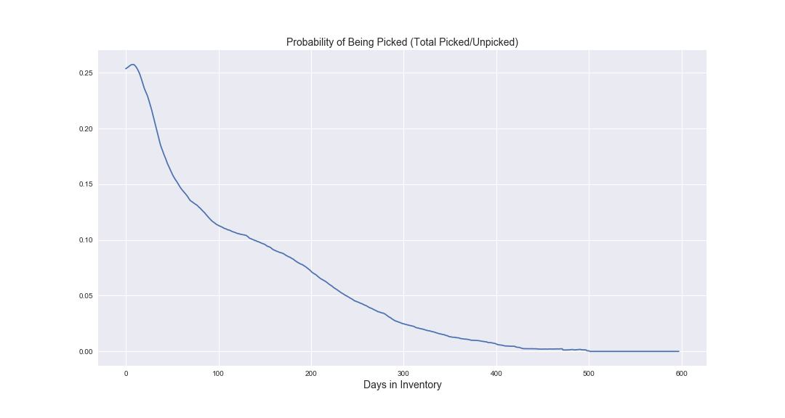
Which modeled looks as the following:
We can quickly get a rough estimate of the likelihood of a unit being picked simply by plugging in the number of days it has been in inventory for.
From the start, a unit only has a ~25% of being picked, simply due to differences in production and usage of COBs. After about 130 days in inventory, this chance falls to ~10%, and is nearly 0% around 400 days.
We can also take a look at the distributions of days in inventory for units selected and not selected:

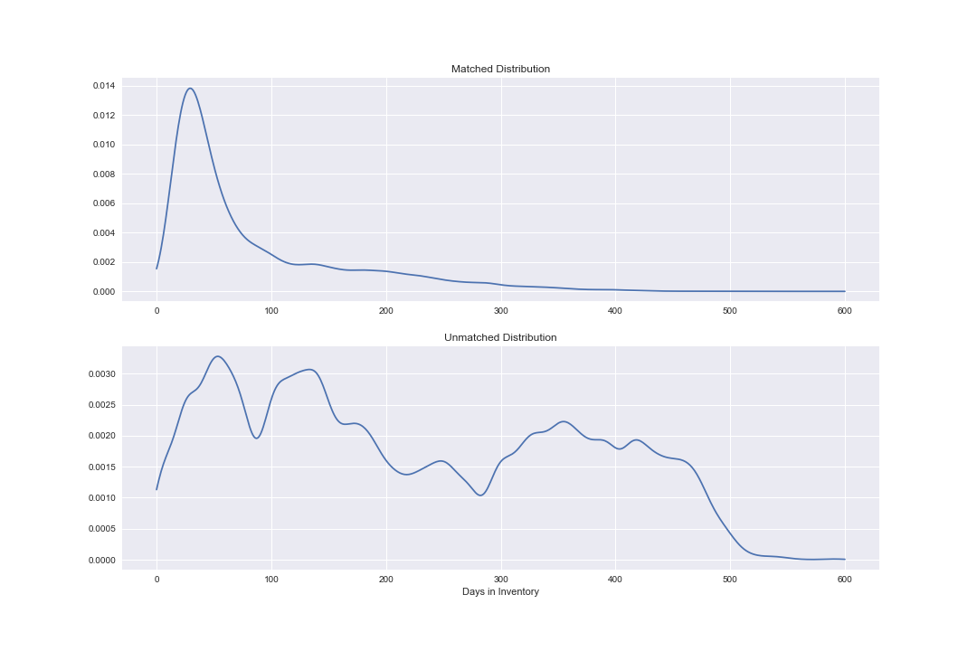
(note: the y-axis is simply a distribution, and does not have much inherent meaning)
A look at these two charts shows quite clearly that the chance of being picked spikes at within the first 30 days of a COB being produced, and rapidly drops off.
The bottom chart shows units that haven’t been picked, the roughly even distribution tells us that units are produced at a pretty regular interval at all times.

6.3 Percentage Chance to be Picked (By COB Test Data)
The next model aims to measure the same thing as the previous, but through COB test data. Thus, this model is much more specific to the COB unit, rather than generalized across all COB historical data.
This model was built simply by labelling COBs as picked when they had a matching LM, and as not picked when they did not (using the same data as the previous model)

Various machine learning classifiers were used for this data. For each model, an accuracy score was calculated to determine whether or not there was actually any predictive capability with the COB test data:
Naïve Bayes Classifier:
- Quick baseline classifier
- Accuracy with outliers removed: 68.7%
- Accuracy with outliers: 41.0%
Support Vector Machine Classifier:
- Trained on 20,000 samples
- Accuracy with outliers removed: 74.9%
- Accuracy with outliers: 73.7%
Random Forest Classifier:
- Trained on 80,000 samples
- Accuracy with outliers removed: 81.0%
- Accuracy with outliers: 81.0%

These models even prior to any hyperparameter tuning achieve moderately high predictive rates. Thus, we have reason to suspect there are desirable test results that some level of selection is being based on. So further explorations on COB test data should produce meaningful results.
Additionally, the random forest classifier provides us with information on the most predictive values:
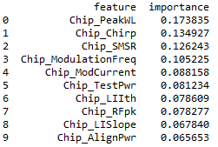
PeakWL is important, as well as Chirp and SMSR as we expected from information from Ted.
Classifiers were not trained on the entire set of data as training was slower for SVM and Forest models, and accuracy did not increase further with more data.
Hence, we may be missing test data needed to more accurately predict chip selection, or otherwise different models/hyperparameter tuning may be needed.

6.4 PCA Visualization
This section is a quick visualization exercise using PCA (principal component analysis).
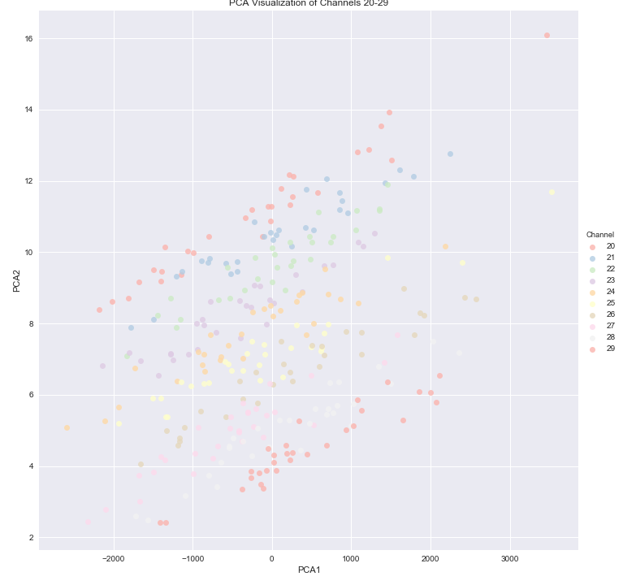
The data was confined to 2 components. In the above graph, COB channels are plotted by channel (as recorded by the ‘PredictChannel’ data column)
Below is the same chart but for all channels between 18 and 64:
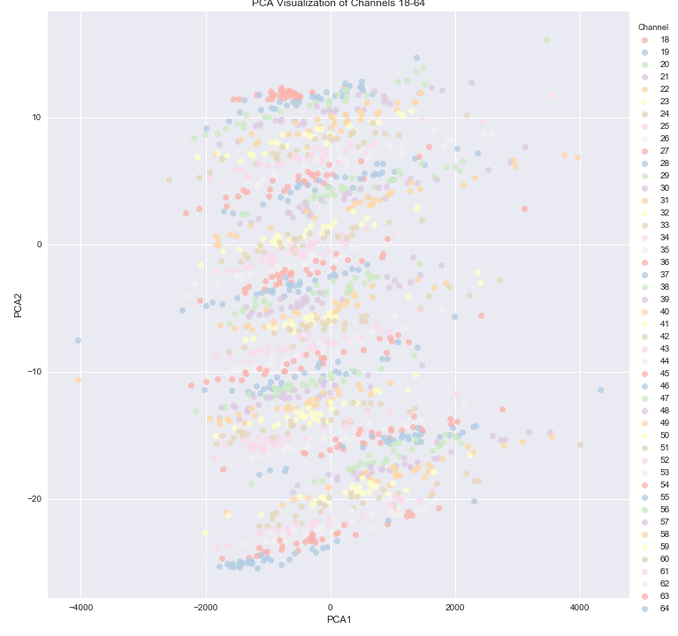
Nothing notably different. The same patterns hold across channels. We might expect there to be clear divisions between channels. But here is a breakdown of the factors in each PCA axis:
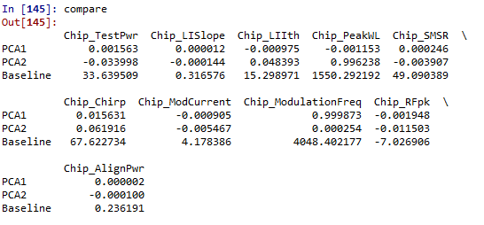
This table gives an idea of what each of the principal components is measuring.
From before, we know that the PCA2 axis is the primary decider of channel, and that is most strongly affected by PeakWL. This is expected, and may simply come from the way predicted channel is assigned.
A simple Naïve Bayes Classifier trained on only the PeakWL actually produces an accuracy score of 89.8% in predicting the value for the predicted channel.
Unfortunately, removing the PeakWL from the PCA produces the following plot:
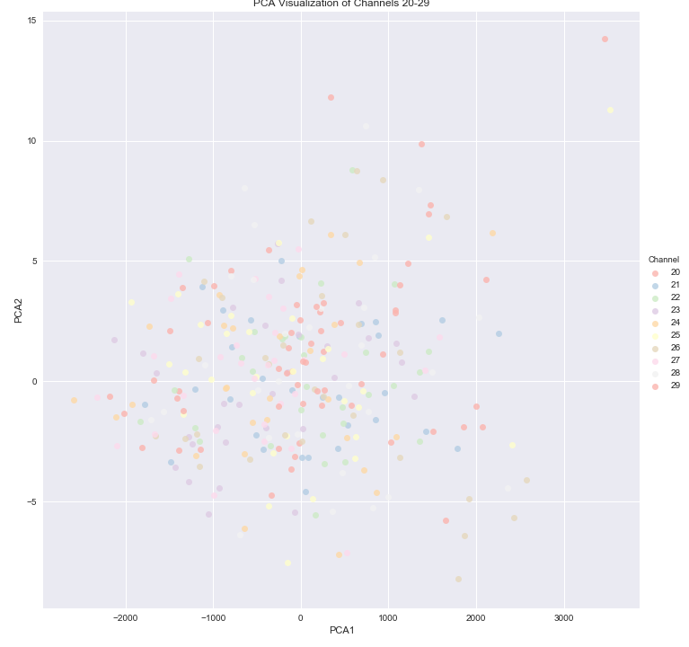
Where there are no longer clear divisions between the PredictChannel values. Hence, there is likely not any merit in attempting to divide data into channels. In fact, the channel information is essentially held within the PeakWL, so any data with that becomes problematic if we are simply selecting COBs based on their channel (which we likely are).

6.5 Revisiting Classifier Models (Chance To Be Picked – COB Data)
Because Wavelength is so strongly correlated to the predicted channel, which in turn is heavily affected by order amount, we would like to know if you can still predict picking likelihood without that information. This is because we’ll be incorporating order data in the weighting of channels by order history and don’t want to double count this information.
Classifier Models, Chip_PeakWL removed
Naïve Bayes Classifier:
- Quick baseline classifier
- Accuracy with outliers removed: 68.7%
Support Vector Machine Classifier:
- Trained on 20,000 samples
- Accuracy with outliers removed: 73.4%
Random Forest Classifier:
- Trained on 80,000 samples
- Accuracy with outliers removed: 75.1%

Only the Random Forest Classifier had a significant decrease in accuracy. Further, lets evaluate the accuracy with the inclusion of Time Spent in Inventory data (merging the two predictive models)
Classifier Models, Chip_PeakWL removed, DeltaDate added
Naïve Bayes Classifier:
- Quick baseline classifier
- Accuracy with outliers removed: 83.5%
Support Vector Machine Classifier:
- Trained on 20,000 samples
- Accuracy with outliers removed: 74.2%
Random Forest Classifier:
- Trained on 80,000 samples
- Accuracy with outliers removed: 95.7%
Although the Random Forest Classifier gets a very high accuracy rating, this may not be an entirely good thing to use. The model likely is only very good at predicting COB pick rates for chips that already have a high inventory date. We can try to run the model again on chips within 100 days (where chips still have a reasonable chance of being picked)

Classifier Models, Chip_PeakWL removed, DeltaDate added, samples of DeltaDate < 100
Random Forest Classifier:
- Trained on 110,000 samples
- Accuracy with outliers removed: 97.9%
The Random Forest Classifier actually does better on samples with fewer than 100 days in inventory. This really shows that the time spent in inventory is the primary predictor for whether or not a unit gets picked. Further outside the 100 days, being picked is an irregularity under the model.
This means we can quite comfortably use the time spent in inventory to predict the value of a COB unit as a percentage chance for it to be picked.

COB Tests Data to LM Test Data Regressions

Target Laser_RFClipping score: 0.00796606043038528
Feature Importance
Chip_PeakWL 0.186086
Chip_Chirp 0.180491
Chip_TestPwr 0.102603
Chip_SMSR 0.096402
Chip_ModCurrent 0.091093
Chip_LIIth 0.081303
Chip_ModulationFreq 0.078411
Chip_AlignPwr 0.075909
Chip_LISlope 0.061317
Chip_RFpk 0.046384

Target Laser_Ith score: 0.6152561595538538
Feature Importance
Chip_LIIth 0.699396
Chip_PeakWL 0.077375
Chip_SMSR 0.040384
Chip_AlignPwr 0.032146
Chip_TestPwr 0.030374
Chip_Chirp 0.025977
Chip_ModCurrent 0.024684
Chip_LISlope 0.024303
Chip_ModulationFreq 0.023827
Chip_RFpk 0.021534

Target Laser_Slopeff score: -0.05958616030258453
Feature Importance
Chip_Chirp 0.375676
Chip_PeakWL 0.159906
Chip_SMSR 0.122399
Chip_ModulationFreq 0.069629
Chip_LIIth 0.059426
Chip_AlignPwr 0.055907
Chip_ModCurrent 0.051799
Chip_TestPwr 0.046399
Chip_LISlope 0.035156
Chip_RFpk 0.023702
Target Laser_Temperature score: 0.018158533818749583
Feature Importance
Chip_PeakWL 0.400665
Chip_SMSR 0.078738
Chip_Chirp 0.076276
Chip_LIIth 0.074993
Chip_ModulationFreq 0.070760
Chip_ModCurrent 0.066852
Chip_AlignPwr 0.063814
Chip_TestPwr 0.061750
Chip_LISlope 0.053886
Chip_RFpk 0.052267

Target Laser_Chirp score: 0.03609856709481907
Feature Importance
Chip_Chirp 0.251479
Chip_PeakWL 0.210326
Chip_SMSR 0.082411
Chip_TestPwr 0.073107
Chip_ModulationFreq 0.072800
Chip_LISlope 0.071437
Chip_LIIth 0.067718
Chip_ModCurrent 0.063677
Chip_AlignPwr 0.063231
Chip_RFpk 0.043816

Target Laser_WaveLen score: -2.171396105404775
Feature Importance
Chip_PeakWL 0.181274
Chip_LIIth 0.126222
Chip_AlignPwr 0.103219
Chip_SMSR 0.101268
Chip_Chirp 0.097758
Chip_TestPwr 0.092208
Chip_ModCurrent 0.091180
Chip_ModulationFreq 0.087447
Chip_LISlope 0.065527
Chip_RFpk 0.053897
Target Laser_SMSR score: -6.0952447872242885
Feature Importance
Chip_Chirp 0.205520
Chip_PeakWL 0.135756
Chip_ModCurrent 0.133150
Chip_SMSR 0.103967
Chip_ModulationFreq 0.096894
Chip_LIIth 0.076770
Chip_AlignPwr 0.064852
Chip_RFpk 0.063566
Chip_TestPwr 0.063562
Chip_LISlope 0.055963

Target Laser_Ibb score: -0.10820481068610406
Feature Importance
Chip_PeakWL 0.163042
Chip_ModulationFreq 0.130444
Chip_SMSR 0.107851
Chip_TestPwr 0.106353
Chip_Chirp 0.106270
Chip_LIIth 0.100632
Chip_AlignPwr 0.082628
Chip_ModCurrent 0.080701
Chip_LISlope 0.067775
Chip_RFpk 0.054305

Target Laser_PowerIbb score: -0.193664618505789
Feature Importance
Chip_PeakWL 0.130374
Chip_Chirp 0.128332
Chip_SMSR 0.117021
Chip_TestPwr 0.110601
Chip_LIIth 0.106099
Chip_ModulationFreq 0.096448
Chip_AlignPwr 0.088201
Chip_LISlope 0.085676
Chip_ModCurrent 0.079755
Chip_RFpk 0.057493
Target Laser_Iop score: 0.15648706012818944
Feature Importance
Chip_ModulationFreq 0.266940
Chip_PeakWL 0.258682
Chip_LIIth 0.080991
Chip_TestPwr 0.072883
Chip_ModCurrent 0.066908
Chip_SMSR 0.066896
Chip_Chirp 0.059716
Chip_AlignPwr 0.047553
Chip_LISlope 0.041232
Chip_RFpk 0.038200

Target Laser_Pop score: -7.380527698022834
Feature Importance
Chip_ModCurrent 0.196857
Chip_ModulationFreq 0.175333
Chip_AlignPwr 0.132929
Chip_Chirp 0.114532
Chip_PeakWL 0.075655
Chip_LIIth 0.075439
Chip_SMSR 0.062408
Chip_TestPwr 0.057714
Chip_RFpk 0.055017
Chip_LISlope 0.054118

Target Laser_CSO_Chirp score: 0.03873516216859721
Feature Importance
Chip_Chirp 0.257438
Chip_PeakWL 0.210502
Chip_SMSR 0.082688
Chip_ModulationFreq 0.071017
Chip_TestPwr 0.070516
Chip_LISlope 0.069361
Chip_LIIth 0.067610
Chip_AlignPwr 0.065046
Chip_ModCurrent 0.061967
Chip_RFpk 0.043855

Above are simple Random Forest Regressive models run between the COB test data and each of the LM test data. The score given for each is the R2 score (closer to 1 is better), and each table shows which pieces of COB data were most relevant.
Unfortunately, only the Laser_Ith test had any potentially significant correlations with this model. Laser_Iop also seemed to have a very small correlation, but not enough to make accurate predictions on.

It is likely that the data is very noisy, and even things like COB_SMSR to Laser_SMSR were not strongly correlated.

